SECTION C: RECOMMENDATIONS TO THE CASE

3.1 Risk Management

3.1.1 Risk Registers

3.1.2 Enhanced Measures for Managing Conflict Risks of Interests

3.1.3 Other Risk Management Measures

3.2 Stakeholder Management

3.2.1 Stakeholder Identification Measures

3.2.2 Information Management System

3.1 Risk Management

3.1.1 Risk Registers

Impact Lifecycle Phase: Planning and Execution

Given the complex challenges identified in Section B, we can conclude as the Risk Events which happed in the Jamuna Bridge project as below:

|  |  |
| --- | --- |
| **No.** | **Risk Event** |
| Badge 1 outline | Resettlement the Char people |
| Badge outline | River regulation works |
| Badge 3 outline | Quality of construction |
| Badge 4 outline | Managing the workforce |
| Badge 5 outline | Polluting the local environment |

Figure xx: the Risk Event Table of the Jamuna Bridge project

“The more detailed the risk event, the more targeted the response” **(Faiello 2024**). After to concrete clear and definite risk events, to implement a risk register start at the planning stage can effectively identify risks early in the project and provide the project team with tools to continuously track these risks in whole lifecycle.

|  |  |  |  |  |  |  |
| --- | --- | --- | --- | --- | --- | --- |
| **Risk Event** | Probability | Impact | Priority | Responsibility | Strategy | Review |
| 1. Resettlement the Char people | Certain | Very High | 25 | Very High |  |  |
| **2. River regulation works** | Certain | High | 20 | Moderation |  |  |
| **3. Quality of construction** | Likely | High | 12 | Moderation |  |  |
| **4. Managing the workforce** | Unlikely | Moderation | 6 | High |  |  |
| **5. Polluting the local environment** | Likely | Moderation | 9 | Moderation |  |  |

Figure xx: the Risk Registers

a. Systematic Risk Classified

The benefits of employing the 5 by 5 priority grid within the risk register, this grid helps categorize risks based on their likelihood and potential impact, allowing the team to conduct a qualitative analysis and prioritize their responses. In the subsequent execution, following a structured approach to respond to project risk.

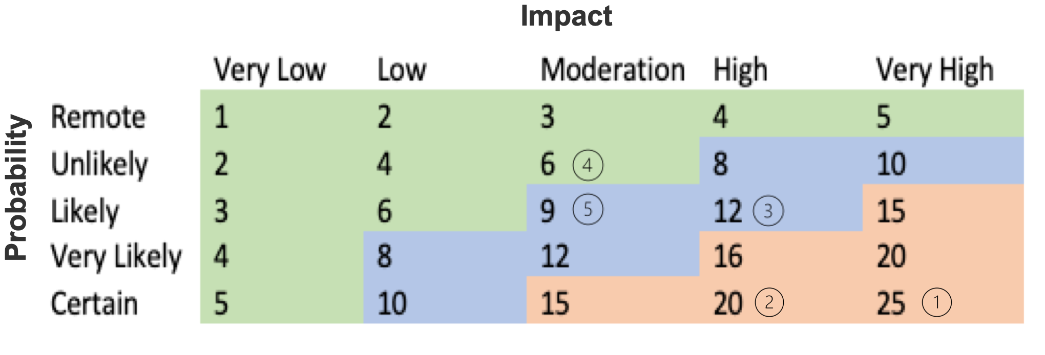

Figure xx: the 5 by 5 Priority Grid

With systematically determine the priority of each identified risk event, can get the figure as below.

|  |  |  |  |  |
| --- | --- | --- | --- | --- |
| **Badge 1 outlineNo.** | **Risk Event** | **Probability** | **Impact** | **Priority** |
| Badge outline | Resettlement the Char people | Certain | Very High | 25 |
| Badge 3 outline | River regulation works | Certain | High | 20 |
| Badge 4 outline | Quality of construction | Likely | High | 12 |
| Badge 5 outline | Managing the workforce | Unlikely | Moderation | 6 |
|  | Polluting the local environment | Likely | Moderation | 9 |

Figure xx: Risk Events with Priority

b. the Risk-Response Matrix

After the analysis is completed, it is necessary to plan the risk response. By applying the Risk-Response Matrix (**Hartley, 2018**),it is easy to plan risk responses. In addition, a clear structured analysis way can quickly determine appropriate coping strategies, reduce analysis and decision time, and improve management efficiency.

Figure xx: the Risk-Response Matrix

c. Monitoring and Control

The continuous tracking of risks using the risk register throughout the project's lifecycle enables the project team to monitor risk responses and make adjustments as necessary. By maintaining this approach, the likelihood of project failure is significantly reduced, and the overall success rate is enhanced. Regular updates to the risk register ensure that emerging risks are captured and that mitigation strategies remain effective.

3.1.2 Enhanced Measures for Managing Conflict Risks of Interests

Impact Lifecycle Phase: Planning and Execution

In addition to technical risks, the project did not take into consideration Vital issues associated with the existence of the Char people, leading to more severe consequences as seen in the Jamuna Bridge project.

a. Establishing an Inspection Panel

An inspection panel should be established early in the planning phase to engage with the Char people. This panel would be responsible for identifying and addressing the needs and placement of the Char people at the processing of the project. By motivated managing these stakeholder concerns, the project can mitigate social risks and foster positive relationships with the affected communities.

b. Holding Regular Risk Review Meetings

To further enhance risk management, set a dedicated communication team to organize regular risk review meetings. These meetings would involve key stakeholders and serve as a platform to discuss the progress of risk management activities, review feedback such as the Char people, and update project documents accordingly. This proactive approach ensures that identified risks are effectively managed and that new risks are promptly addressed, preventing major disruptions to the project.

3.1.3 Other Risk Management Measures

a. Safety risk: Implement strict safety procedures, conduct regular safety training for all personnel, and continuously monitor safe operation on site to prevent accidents and ensure a safe working environment.

b. Environmental risks: Conduct a thorough environmental impact assessment, obtain all necessary environmental permits, and implement mitigation measures to minimize the impact of the project on the surrounding environment.

c. Regulatory and Legal Risk: Establish a strong legal and regulatory team to deal with the complex legal environment, ensure that the project complies with all relevant laws and regulations, and reduce the risk of legal challenges.

d. Project management risk: Using the best practices of project management and supported by advanced project management software, regularly training project managers to improve their skills and ensure effective project management.

3.2 Stakeholder Management

3.2.1 Stakeholder Identification Measures

Impact Lifecycle Phase: Planning and Execution

a. Stakeholder Power and Interests Matrix

A Stakeholder Rights and Interests Matrix should be developed to identify and analyze the attributes of each stakeholder. This matrix helps the project team understand how the satisfaction levels of different stakeholders can impact the project, particularly those stakeholders with the highest influence. Based on this analysis, the project team can develop tailored communication strategies, risk responses, and other project-related documentation that addresses the needs and concerns of each stakeholder group.

Figure xx: Stakeholder Power And Interest Matrix

b. PARIS Framework

To ensure that the roles and responsibilities of all stakeholders are clearly defined, the PARIS framework should be applied. This framework helps to reduce communication issues and delays caused by unclear responsibilities by ensuring that each stakeholder is appropriately informed and involved at the right time.

* Participate: During the project planning phase, the project manager and team members should be designated as participants responsible for developing the project plan.

* Approve: The project's sponsor or executives should be responsible for approving key aspects such as budget approvals and critical milestones, ensuring that the project aligns with organizational goals.

* Responsible: The project manager should be responsible for communicating with the Char people, ensuring that their resettlement is carried out according to the plan, and addressing any concerns that may arise during the process.

* Inform: The project's clients and external stakeholders should receive regular progress reports to keep them informed of the project's status and any changes that may impact them.

* Signoff: The roles of stakeholders who will provide final acceptance and sign-off on the project's key deliverables should be clearly defined. This ensures that the results of each major phase are formally acknowledged, with a client representative signing off on the final acceptance document upon project completion.

3.2.2 Information Management System

Impact Lifecycle Phase: Concept and Planning

1. Placement Personnel Database

To manage the resettlement of nearly 100,000 people affected by the construction of the Jamuna Bridge (**The World Bank 2000**), an information management system should be implemented from the initial planning stage. This system would compile and record detailed information on all affected residents, allowing the project team to develop fair and transparent compensation and resettlement plans. The system should also track the progress of resettlement activities, ensuring that all commitments are fulfilled and that any issues are promptly addressed. This approach not only helps to mitigate social risks but also fosters trust and cooperation between the project team and the affected communities.

1. Procurement Management System

A comprehensive procurement management system should be implemented to ensure that all necessary goods and services are acquired efficiently and within budget. This system would also provide effective control over people of the supply chain, ensuring that accountability is maintained throughout the project. By tracking the source and usage of materials, the project team can make sure the responsibility is placed on the person or the team.

Reference:

Faiello, C 2024, *Risk management: Proactively managing uncertainty, complexity and change*, lecture notes distributed in Project Management & Engineering Practice 7 at The University of Western Australia, Crawley on 27 August 2024.

Hartley, S., 2018, *Project management: a practical guide to planning and managing projects. 4th ed.*, Allen & Unwin, Australia.

The World Bank 2000, *IMPLEMENTATION COMPLETION REPORT t*. Available from: Document of

The World Bank. [19 June 2000].